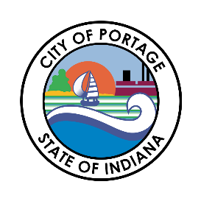
CITY OF PORTAGE COMMON COUNCIL
SPECIAL MEETING AGENDA
February 24, 2026
6:30 PM

Call to Order
Austin Bonta
Mayor

Elizabeth Modesto
Clerk-Treasurer

Ferdinand Alvarez
At-Large

Melissa Weidenbach
At-Large

Gina Giese-Hurst
1st District

Bob Parnell
2nd District

Victoria Vasquez
3rd District

Penny Ambler
4th District

Collin Czilli
5th District
- Pledge of Allegiance
- Roll Call
- Introduction of Ordinances
  - Ordinance #26-03 Port Authority Matters
- Introduction of Resolutions
  - Resolution #26-04 Allow Clerk-Treasurer to Clear Stale Checks
- Other Matters Considered by the Council
  - Public Works Addendum
- Adjournment

