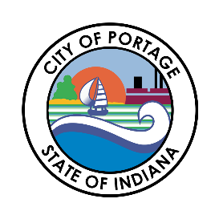
CITY OF PORTAGE COMMON COUNCIL
MEETING AGENDA
February 3, 2026
6:30 PM

Call to Order
Austin Bonta
Mayor

Elizabeth Modesto
Clerk-Treasurer

Ferdinand Alvarez
At-Large

Melissa Weidenbach
At-Large

Gina Giese-Hurst
1st District

Bob Parnell
2nd District

Victoria Vasquez
3rd District

Penny Ambler
4th District

Collin Czilli
5th District
- Pledge of Allegiance
- Roll Call
- Approval of Minutes
- Communications, Correspondence, Announcements from the Mayor
  - Portage Moose presenting Comfort Stuffed Mooses to the City of Portage for Distribution
  - Swear in 3 New Police Officers: Nolan Owensby, Cooper Jones, Bryce Hufford
- Clerk Treasurer’s Report
- Petitions, Remonstrances and Public Input
- Reports from Standing Committees
- Reports from City Officials
- 2nd Reading of Ordinance
  - Ordinance #26-01 Sweetwater Annexation
- Introduction of Ordinances
  - Ordinance #26-02 Amending 2026 Salary Ordinance
- Introduction of Resolutions
- Any Matters Not Already Considered by the Council
- Adjournment

