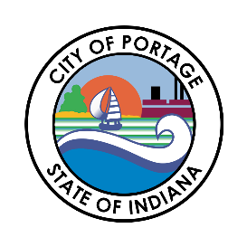
CITY OF PORTAGE COMMON COUNCIL
MEETING AGENDA
March 3, 2026
6:30 PM

Call to Order
Austin Bonta
Mayor

Elizabeth Modesto
Clerk-Treasurer

Ferdinand Alvarez
At-Large

Melissa Weidenbach
At-Large

Gina Giese-Hurst
1st District

Bob Parnell
2nd District

Victoria Vasquez
3rd District

Penny Ambler
4th District

Collin Czilli
5th District
- Pledge of Allegiance
- Roll Call
- Approval of Minutes
- Communications, Correspondence, Announcements from the Mayor
  - Swear in 5 New Firefighters: Nathan Brandt, Noah Villarreal, Ryan Mattell, Derek Kunzman, Tyler Foster
  - Firefighter Promotions
  - Swear in 1 New Police Officer: Noah Bugos
- Clerk Treasurer’s Report
- Petitions, Remonstrances and Public Input
- Reports from Standing Committees
- Reports from City Officials
- Introduction of Ordinances
- 2nd Reading of Ordinance
  - Ordinance #26-03 Port Authority Matters
- Introduction of Resolutions
  - Resolution #26-02 Personal Property Tax Abatement Faerch Portage, Inc.
  - Resolution #26-05 Additional Appropriation Lit to MVH
  - Resolution #26-06 Preliminary Bond Reimbursement
  - Resolution #26-07 NIPSCO Transparency Concerns
- Other Matters Considered by the Council
  - Public Works Addendum
- Any Matters Not Already Considered by the Council
- Adjournment

