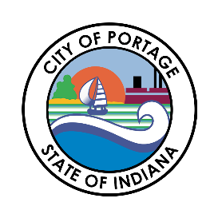
CITY OF PORTAGE
BOARD OF PUBLIC WORKS & SAFETY
AGENDA
February 24, 2026
10:30 AM
Austin Bonta
Mayor

Elizabeth Modesto
Clerk-Treasurer

Jennifer Newell
Member

Jamie Lewis
Member

Frank Farkas
Member

Andy Maletta
Member
- Call to Order
- Pledge of Allegiance
- Roll Call
- Approval of Minutes – 01/27/2026
- Unfinished Business
- New Business
  - Special Event Request-Humane Society of Hobart
  - Marina Shores Yacht Club Event Dates
  - Providence Homes Farmington Bond
- BOW Claims
  - 02/24/2026
- Payroll Claims
  - 02/06/2026 Payroll Claims
- Bulk Appeals
  - 3191 May St
  - 5699 Brookview Ave
  - 2966 Glenwood St
  - 6686 Portage Ave
- Any Other Business Deemed Proper to be Brought Before the Board
- Adjournment

