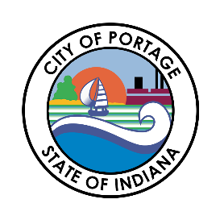
CITY OF PORTAGE
BOARD OF PUBLIC WORKS & SAFETY
AGENDA
January 27, 2026
10:30 AM
Austin Bonta
Mayor

Elizabeth Modesto
Clerk-Treasurer

Jennifer Newell
Member

Jamie Lewis
Member

Frank Farkas
Member

Andy Maletta
Member
- Call to Order
- Pledge of Allegiance
- Roll Call
- Approval of Minutes – 01/13/2026
- Unfinished Business
- New Business
  - Nativity Fest Event Permit
  - Indiana Elite Soccer Club Event Request
  - Cender Dalton 2026 Annual Consultant Agreement
- BOW Claims
  - 01/27/2026
- Payroll Claims
  - 12/26/2025 Payroll Claims
  - Dec 2025 Pension Payroll
  - 01/09/2026 Payroll Claims
- Bulk Appeals
  - 1987 Jefferson St
  - 3172 St Julian St
  - 2839 May St
  - 6330 Savannah
- Any Other Business Deemed Proper to be Brought Before the Board
- Adjournment

